**Local model execution using Ollama**

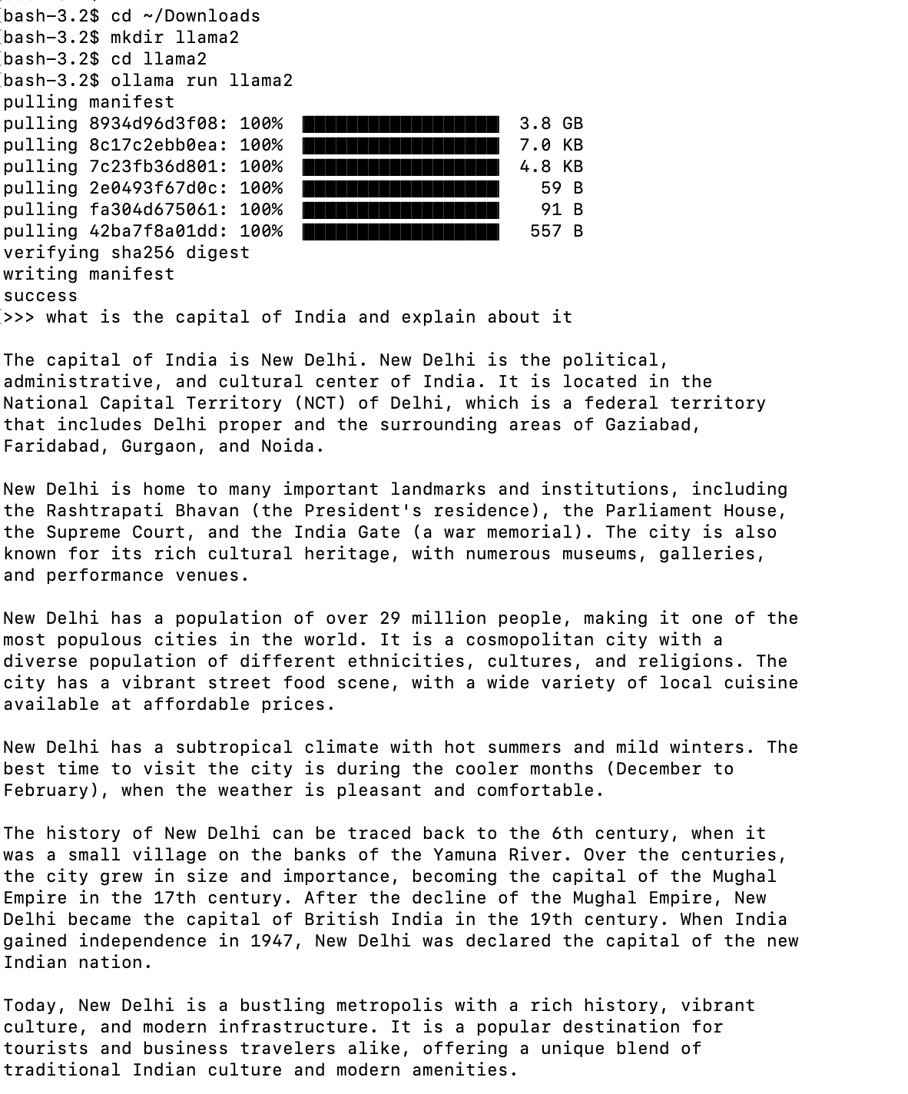

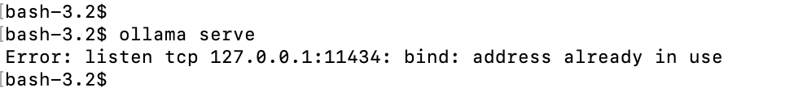

**Ollama command reference:**

* ollama run llama2
* ollama list
* ollama serve
* ollama –help
* ollama rm llama2